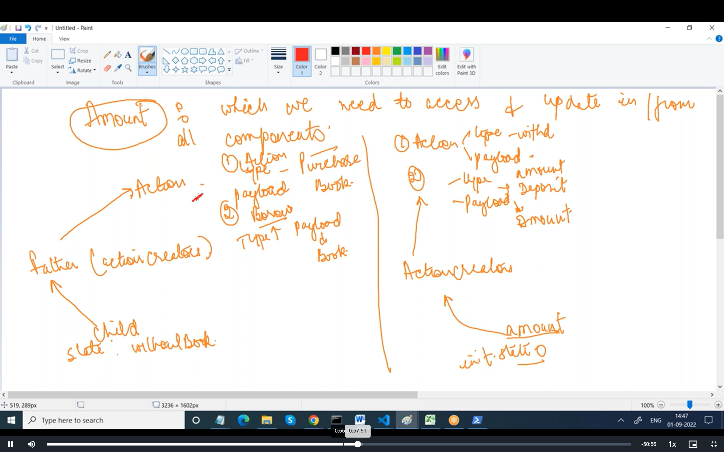

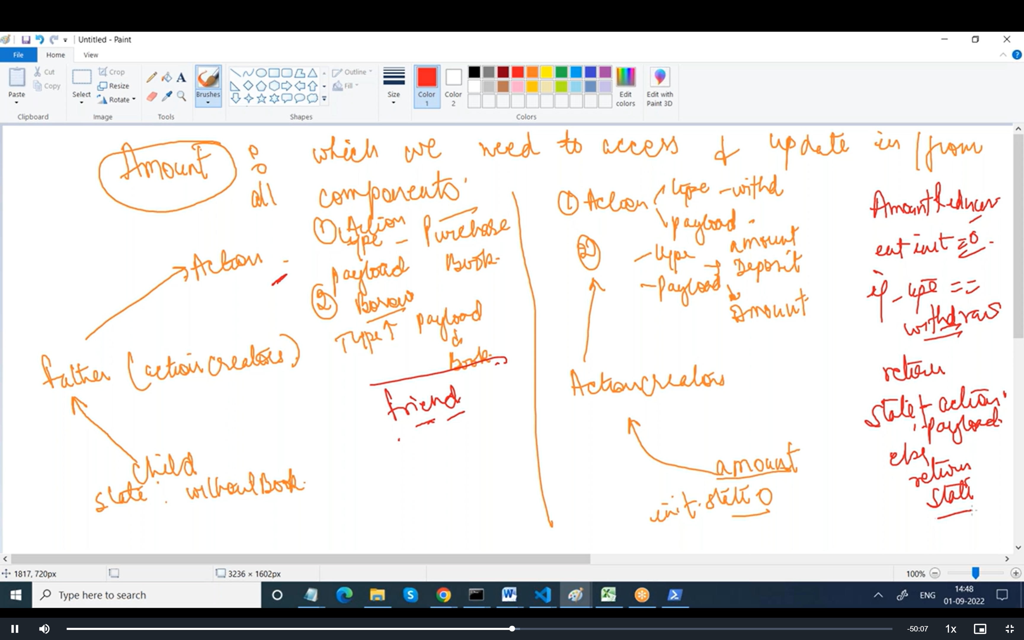

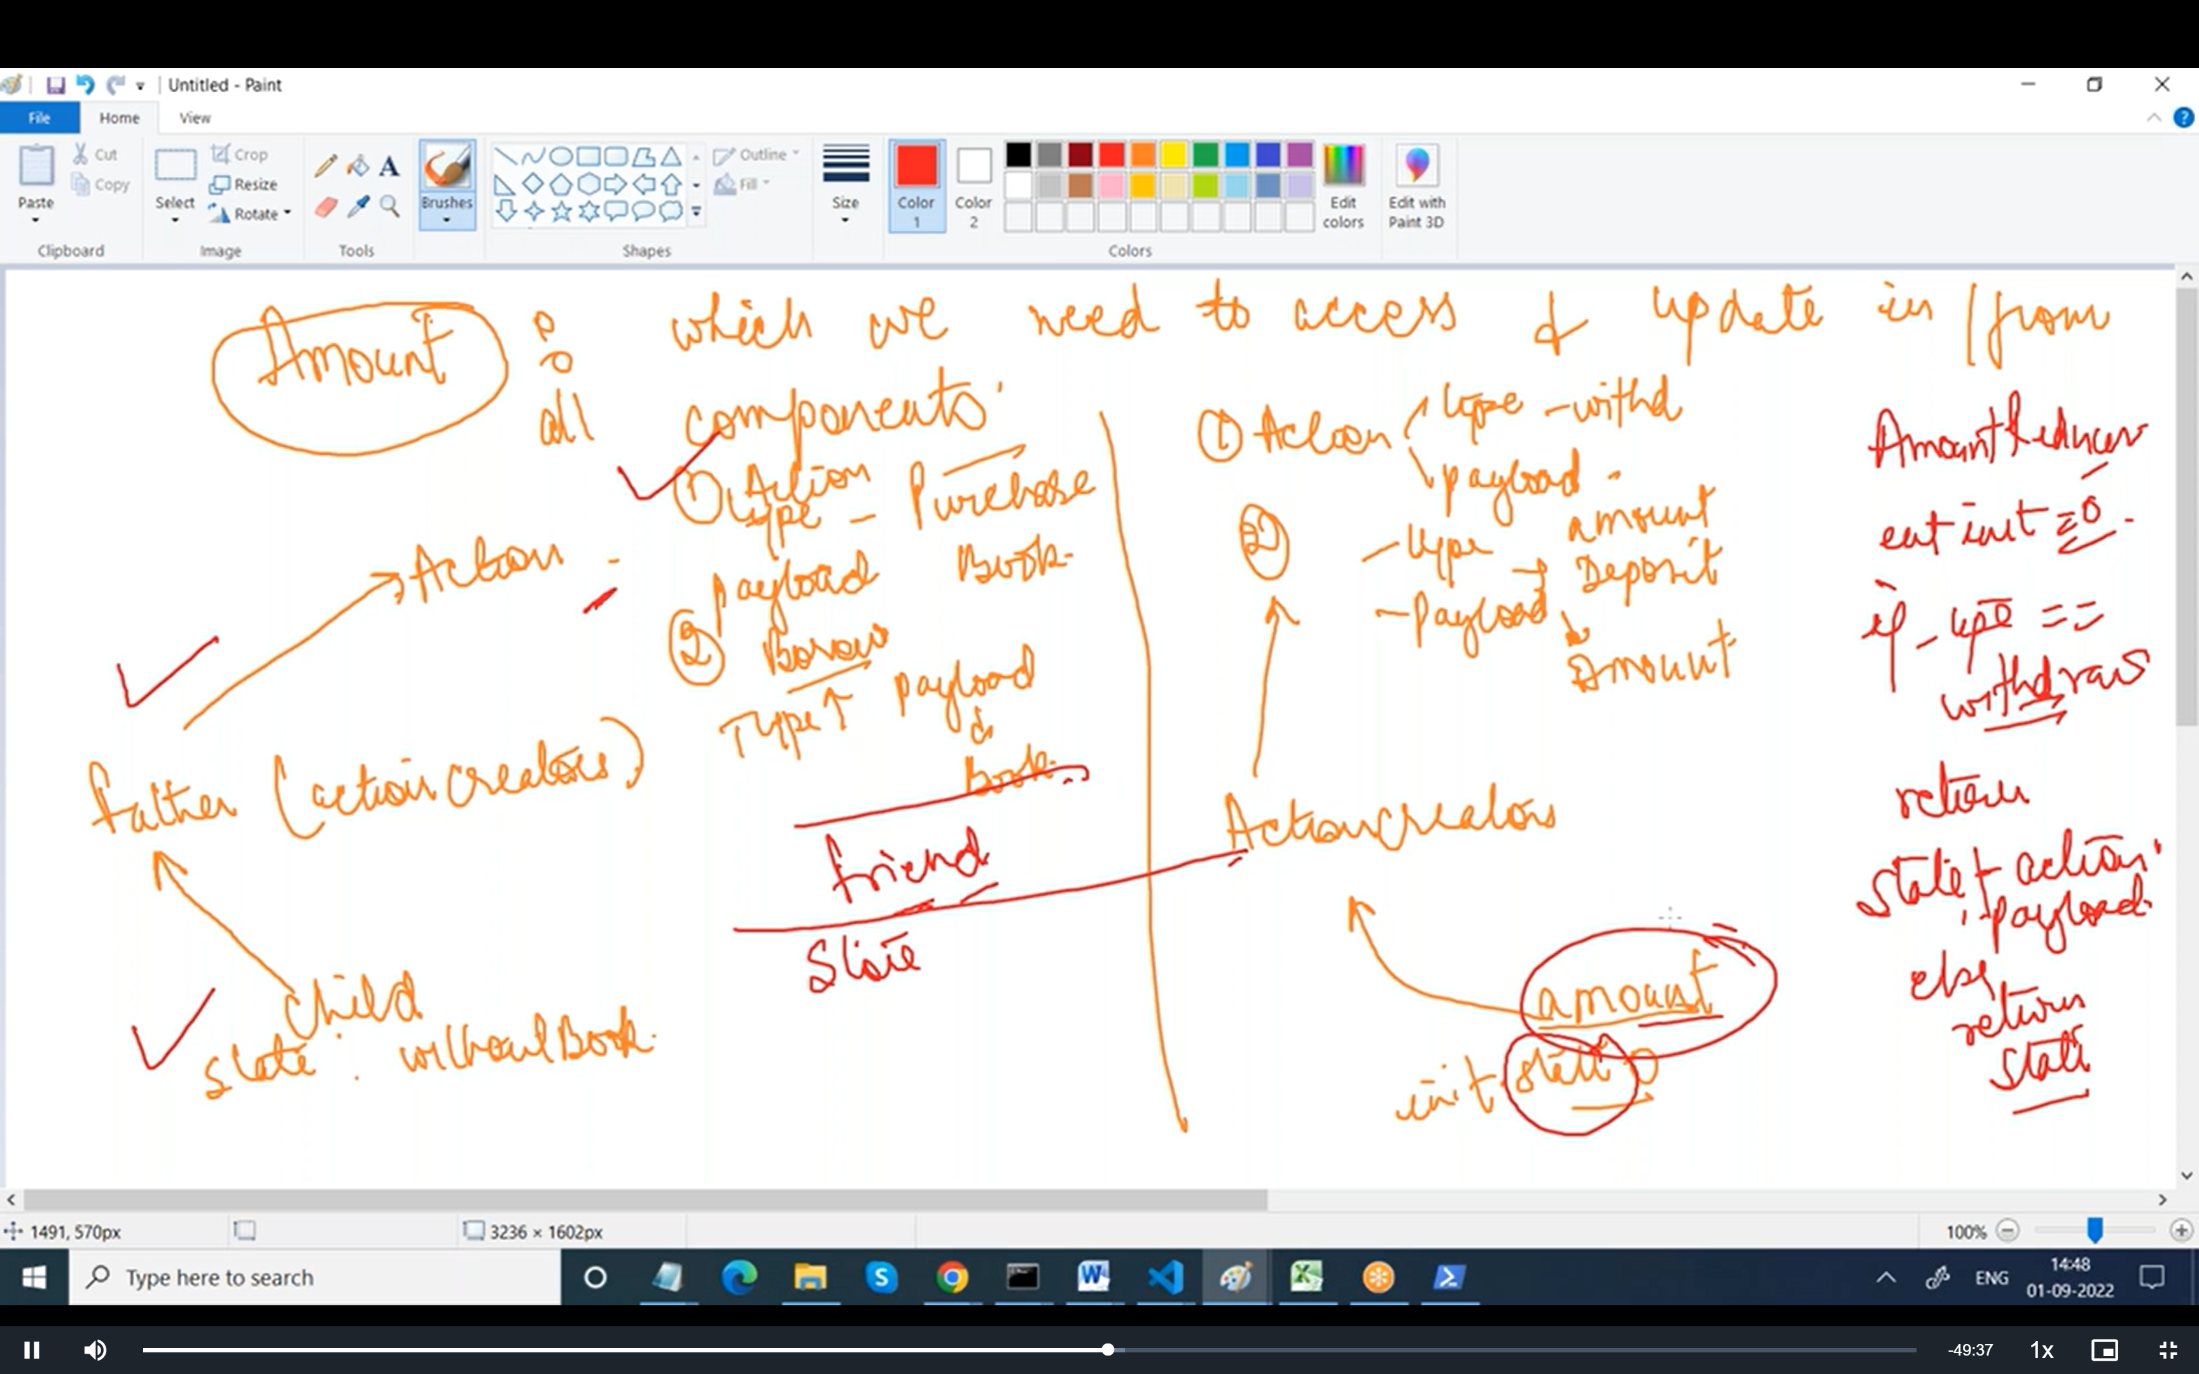

ActionCreator.js

export const depositMoney =(amount)=>

{

return(dispatch)=>

{

  dispatch({

    type:'deposit',

    payload:amount

  })

}

}

export const withdrawMoney =(amount)=>

{

  return(dispatch)=>

  {

    dispatch({

      type:'withdraw',

      payload:amount

    })

  }

  }

Reducer

AmountReducer.js

const init =0;

const reducer = (state=init, action)=>

{

   console.log("AAA"+ action.type)

  if(action.type==='deposit')

  {

     return state + action.payload;

  }

  else if(action.type==='withdraw')

   {  return state - action.payload;

       }

       else

 {      return state;

 }

  }

  //  switch(action.type)

//  {

//    case 'deposit' :

//     return state + action.payload;

//  case 'withdraw':

//   {  return state - action.payload;

//       }

//       default :

// {      return 0;

// }

//  }

export default reducer;

Combine all reducers

import { combineReducers } from "redux";

import amountreducer from "./amountreducer";

const reducers = combineReducers(

  {

    amount:amountreducer

  }

)

export default reducers;

index file in action to combine all actions

export * as actionCreators from './actionCreator';

store

import {applyMiddleware, legacy_createStore} from "redux";

import thunk from "redux-thunk";

import reducer from "./index1";

const store1 = legacy_createStore(reducer ,{},

  applyMiddleware(thunk))

console.log("v"+ store1.getState());

  export default store1;

Index.js

import React from 'react';

import ReactDOM from 'react-dom/client';

import { BrowserRouter as Router, Switch, Route } from "react-router-dom";

import './index.css';

import App from './App';

import reportWebVitals from './reportWebVitals';

import { Provider } from 'react-redux';

import store1 from './reducers/store';

//  store.subscribe(()=> {console.log(store.getState())})

const root = ReactDOM.createRoot(document.getElementById('root'));

root.render(

  <React.StrictMode>

 <Provider store={store1}>

      <App />

    </Provider>

  </React.StrictMode>

);

// If you want to start measuring performance in your app, pass a function

// to log results (for example: reportWebVitals(console.log))

// or send to an analytics endpoint. Learn more: https://bit.ly/CRA-vitals

reportWebVitals();

Shop.js

import React from 'react'

export default function   Shop  () {

  return (

    <div>

      <h1> Deposit / Withdraw Money </h1>

      <button className='btn btn-primary'> +  </button>

      Update Balance

      <button className='btn btn-primary'> -  </button>

        </div>

  )

}

Update State

import React from 'react'

import { useDispatch } from 'react-redux'

import { bindActionCreators } from 'redux';

import { actionCreators } from './reducers/index2';

export default function   Shop  () {

  const dispatch = useDispatch();

  return (

    <div>

      <h1> Deposit / Withdraw Money </h1>

      <button onClick={()=> {dispatch(actionCreators.depositMoney(100))}} className='btn btn-primary'> +  </button>

      Update Balance

      <button className='btn btn-primary'> -  </button>

        </div>

  )

}

Shop.js

import React from 'react'

import { useDispatch } from 'react-redux'

import { bindActionCreators } from 'redux';

import { actionCreators } from './reducers/index2';

export default function   Shop  () {

  const dispatch = useDispatch();

const {depositMoney, withdrawMoney} = bindActionCreators(actionCreators,dispatch);

  return (

    <div>

      <h1> Deposit / Withdraw Money </h1>

      {/* <button onClick={()=> {dispatch(actionCreators.depositMoney(100))}} className='btn btn-primary'> +  </button>   */}

      <button onClick={()=>depositMoney(100)} className='btn btn-primary'> +  </button>

      Update Balance

      <button onClick={()=>withdrawMoney(100)}  className='btn btn-primary'> -  </button>

        </div>

  )

}